## Introduction

In the middle of the COVID-19 pandemic, there has been a significant rise in the use of online platforms to express mental health concerns globally. This surge in online activity, particularly on social media platforms, highlights the role of these platforms not only in facilitating user interactions but also in providing a space for personal expressions. Consequently, our research aims to investigate the outcomes demonstrated in these online forums before and after the stressor that is COVID-19, and come to a conclusion on how it has influenced them, specifically in the case of post trends and post engagements within mental health-related subreddits.

**Research Question:**

Does COVID impact post trends and engagements within mental illness-related subreddits?

**Hypothesis:**

Mental health-related subreddits will exhibit a shift in post trends as well as the number of engagements, such as post text, number of comments, score and upvote ratios, between the pre-COVID and post-COVID periods.

Our study will focus on Reddit posts from 9 specific mental health-related subreddits: depression, ADHD, anxiety, bipolar, PTSD, schizophrenia, eating disorders, brain fog, and suicide watch. The datasets from these subreddits will include title text, post texts, score, upvote ratio, number of total comments, and the post’s creation time. We will analyze these features to observe changes in both post trends and engagement before and after the COVID-19 pandemic. Through text classification and time series analysis, we will transform these features into valuable variables for our analysis.

To address ethical concerns, it is important to clarify that our research does not aim to measure the mental health status of users or use any personal information they might display on the forum. Instead, we will analyze how posts themselves have changed over time. Additionally, we will ensure that our use of Reddit data is in compliance with platform policies and guidelines.

## ETL

Our data collection process begins with extracting data from the Reddit API. This involves web scraping, through which we gathered the top posts from nine different subreddits on a monthly basis from 2018 to 2022. These subreddits represent the nine most popular communities focusing on mental health, providing a comprehensive source of information on mental health-related posts.

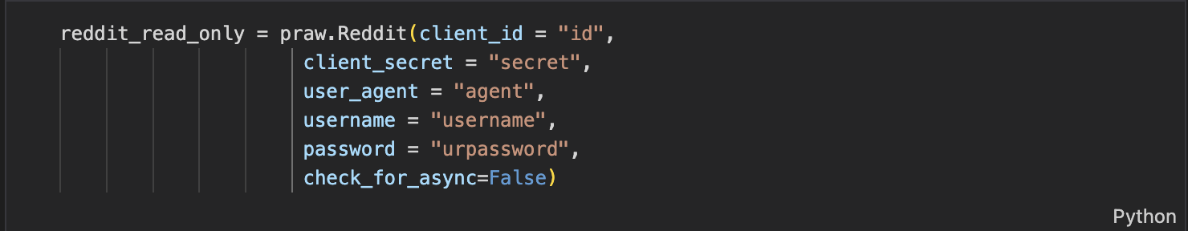

**Figure1. Praw Reddit to connect with Reddit API**

Using Praw library to extract specific subreddit and features from Reddit API, and extracting depression subreddit.



**Figure 2. Depression subreddits**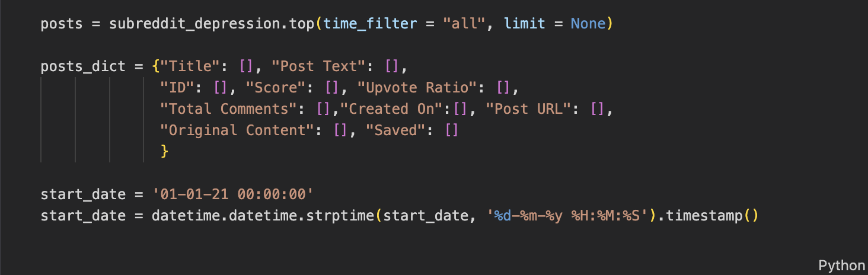

**Figure 3. Depression subreddits - features and timeframe of dataset**

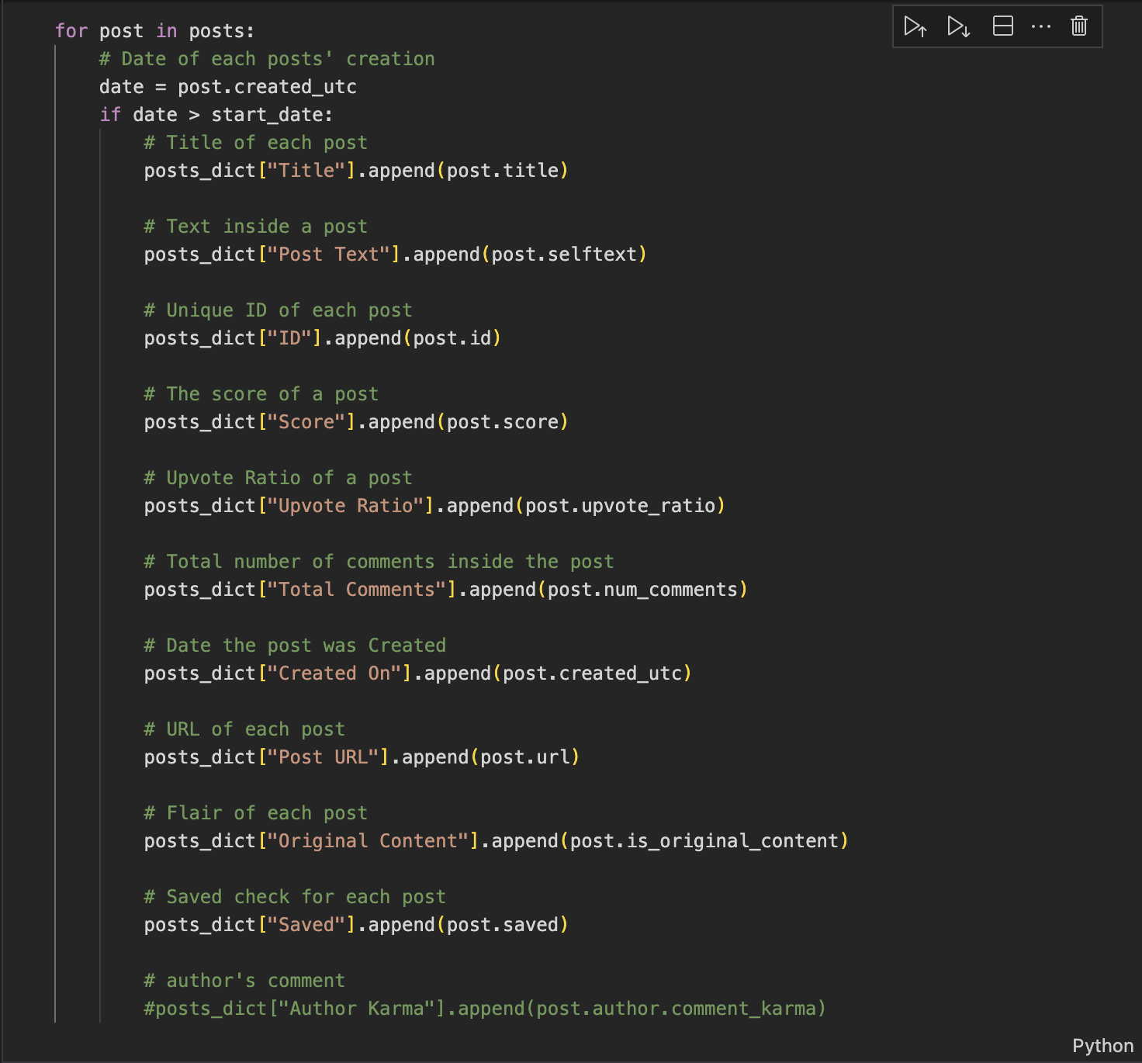

**Figure 4. Depression subreddits - features extraction**

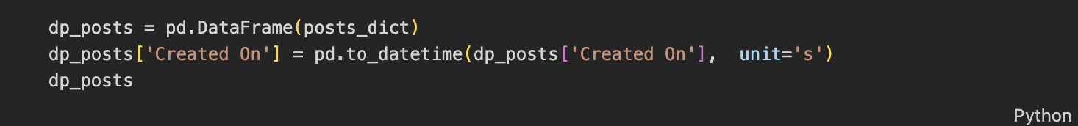

**Figure 5. Final Depression subreddits into dataframe**

We selected top posts from the period between 2018 to 2022, considering posts from 2018 to January 2020 as pre-COVID and February 2020 to 2022 as post-COVID. From the Reddit API, we extracted useful features using quantitative methods for our research. This dataset provides a comprehensive population to analyze users’ activities on mental health-related posts at any given time. To mitigate the sampling bias, the dataset contains 9 different subreddits, allowing us to control for any methodological variations.

## EDA

Below is the sample of our dataset that combines all 9 subreddits.

From this dataset, we will be using Title, Post Text, Score, Upvote Ratio, Total Comments, Created on to perform our analysis.

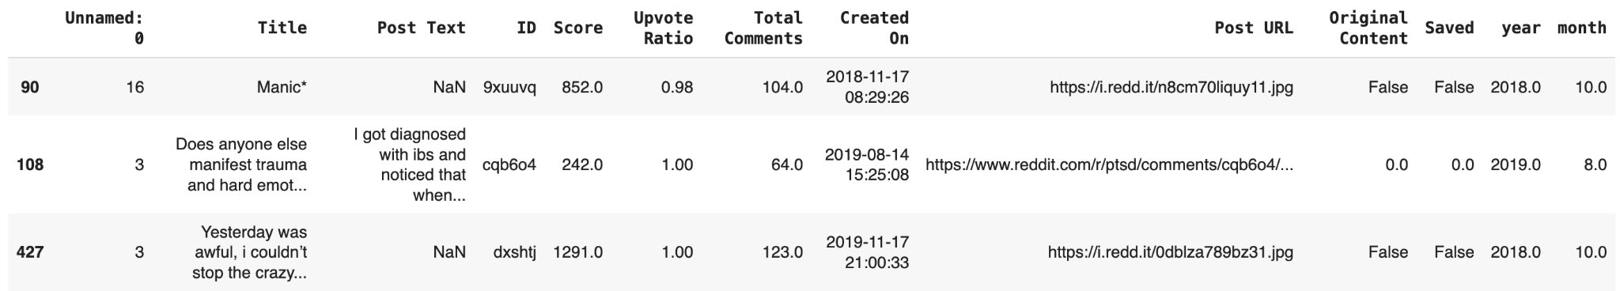

**Figure 6. Pre-COVID sample data**

First, we studied the post length of the dataset. We calculated post length by counting the letters of the post text. Post length, along with title length, will be used to determine post trends for our time series analysis. As the below graphs of the post length distribution show, the subreddits have longer post length in Post-COVID compared to pre-COVID.

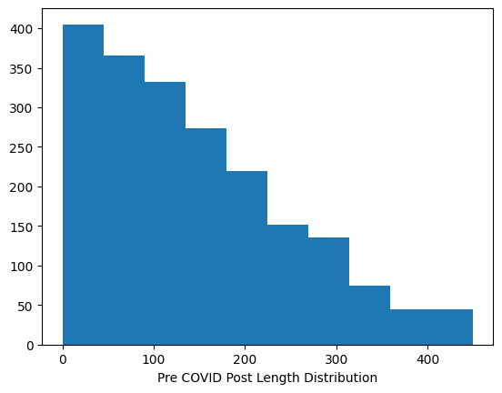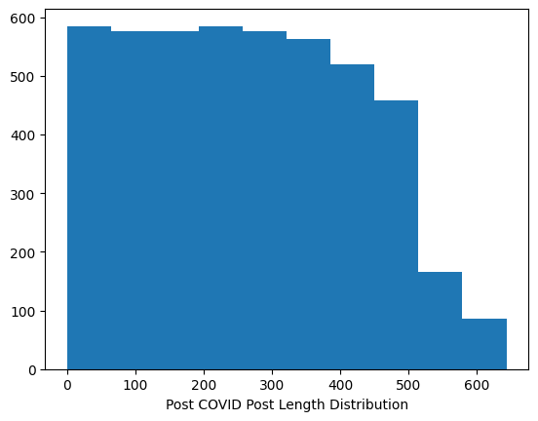

**Figure 7. Post Length Distribution Pre-COVID vs. Post-COVID**

However, we will use Log Transformation of the features to reduce skewness of data and to normalize the raw dataset.

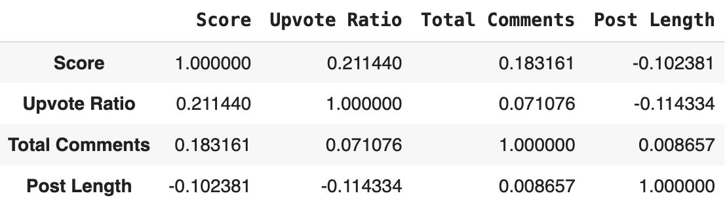

**Figure 8. Pre-COVID Log transformed using Pearson’s**

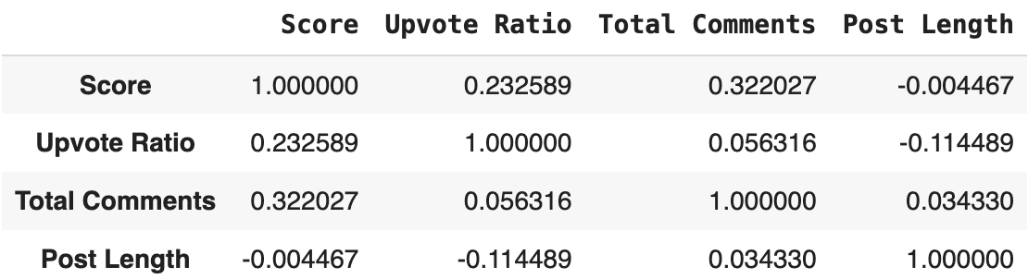

**Figure 9. Post-COVID Log transformed using Pearson’s**

**Correlation matrices using log transformation**

Based on the correlation matrices, we can see that there is a stronger correlation between score with upvote ratio and total comment post-COVID than during pre-COVID. However, both periods show a positive correlation between Score, Upvote Ratio and Total Comments, so it’s safe to assume that they can be helpful in determining a pattern in post engagement.

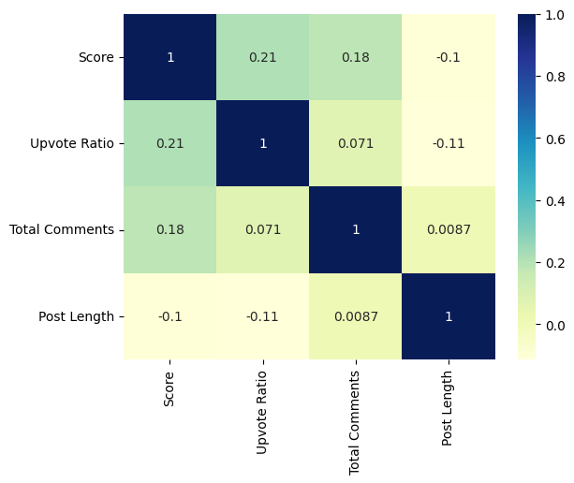

**Figure 10. Correlation between log features - Pre-COVID**

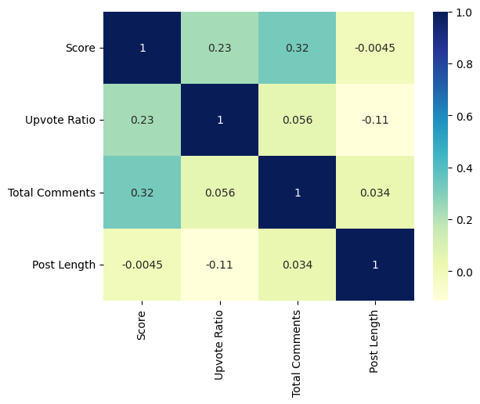

**Figure 11. Correlation between log features - Post-COVID**

**Log trans features**

Even though we are just taking the log of post length for both periods, it is observed that post length is significantly larger in post-COVID.

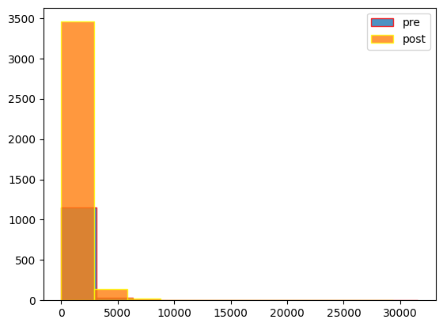

**Figure 12. Log Post Length pre-COVID VS post-COVID**

As a result, the count of Scores is also higher for post-COVID. But generally, the scores are also higher post-COVID compared to pre-COVID.

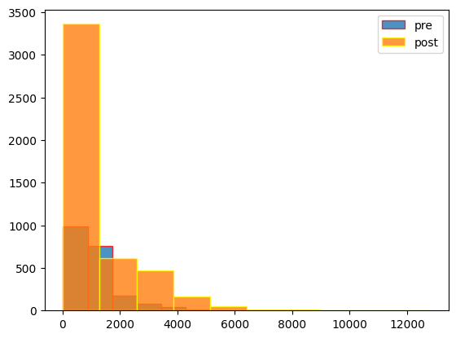

**Figure 13. Log Score pre-COVID vs post-COVID**

There are also more comments on our subreddits in the post-COVID period, indicating people tend to express themselves online more after COVID.

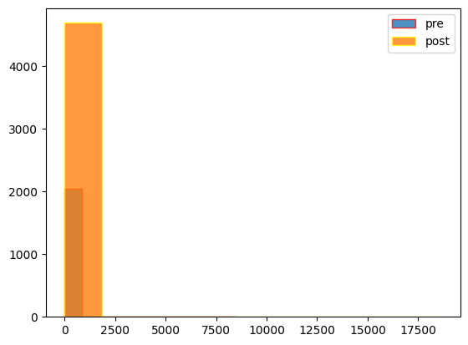

**Figure 14. Log Total Comments pre-COVID vs post-COVID**

Upvote Ratio stays around the same pre-COVID and post-COVID since this is a score out of 1, there should not be any difference between them.

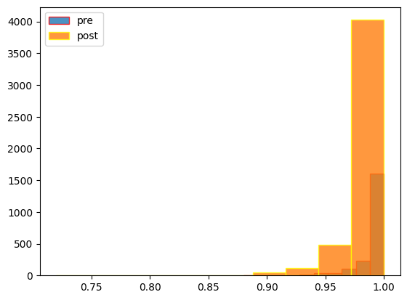

Figure 15. Log Upvote Ratios pre-COVID vs. post-COVID

**Central tendency**

The central tendency describes the central or typical value around which our datasets tend to cluster. Our statistics for the variables are as follows:

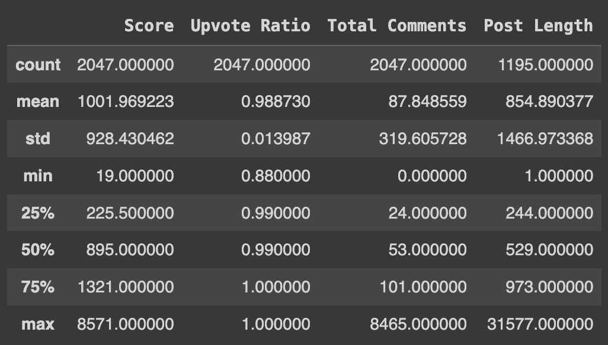

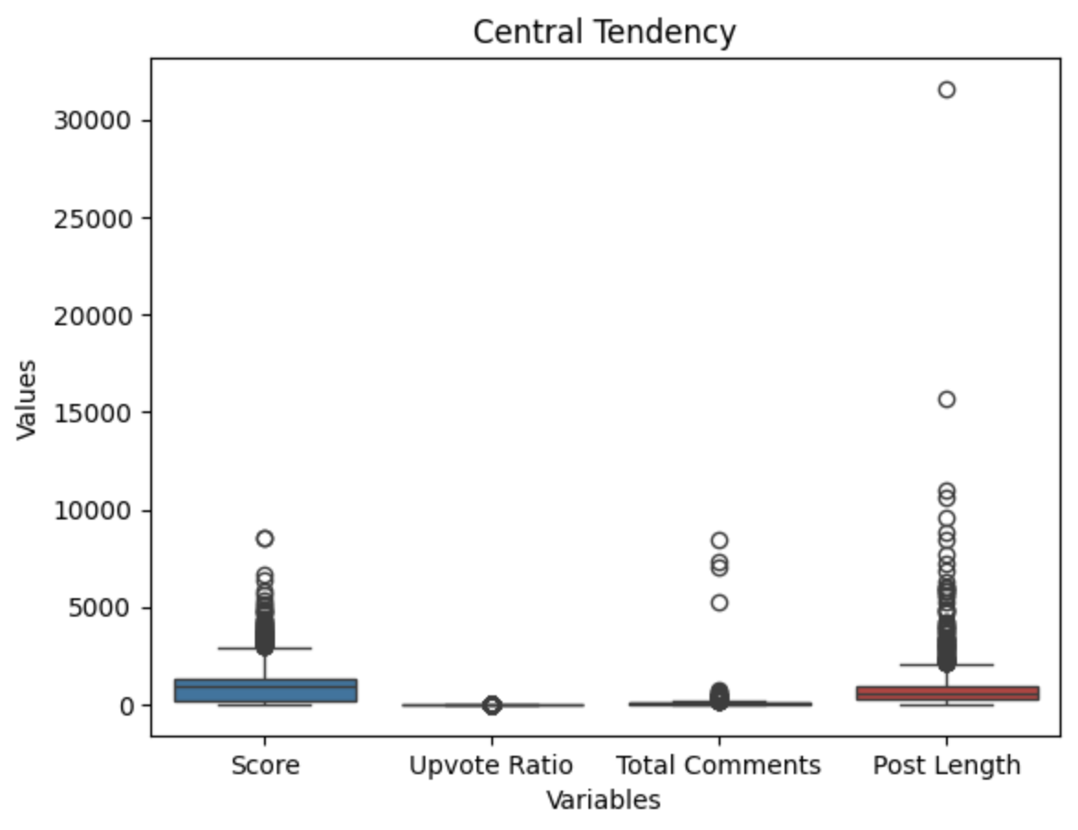

**Figure 16. Central Tendency of each feature**

## Text Classification

BERT (Bidirectional Encoder Representations from Transformers) has become one of the most popular models to solve a wide range of natural language processing tasks with high accuracy. It is developed by Google AI Language which applies the bidirectional training of Transformer, in contrast from previous models that looked at text sequence either from left to right or combined left-to-right and right-to-left training. In this research, we utilized BERT pretrained model from PyTorch Huggingface for BERT and DistillBERT to proceed text classification on pre and post COVID, moreover, we also used BERT Topic Modeling for visualizing top words from pre and post COVID.

In our BERT model, we employ binary classification with balanced samples to compare pre and post-COVID post texts. Specifically, our classification utilizes a balanced sampling approach, drawing 50 percent of the data from pre-COVID and 50 percent from post-COVID, resulting in 2047 data points for each period. This approach helps mitigate bias that could arise from larger datasets dominating the results, allowing us to more accurately identify differences between the two datasets.

Furthermore, it is important to note that our binary classification model is not solely focused on achieving higher accuracy. While higher accuracy is desirable, our primary objective is to compare pre and post-COVID post texts. To this end, we also employ topic modeling to identify which topics are prevalent within each dataset.

Basically, our BERT model contains five steps:

1. Import data
2. Preprocessing the data
3. Tokenization
4. BERT model
5. Model Evaluation

**Steps for BERT model**

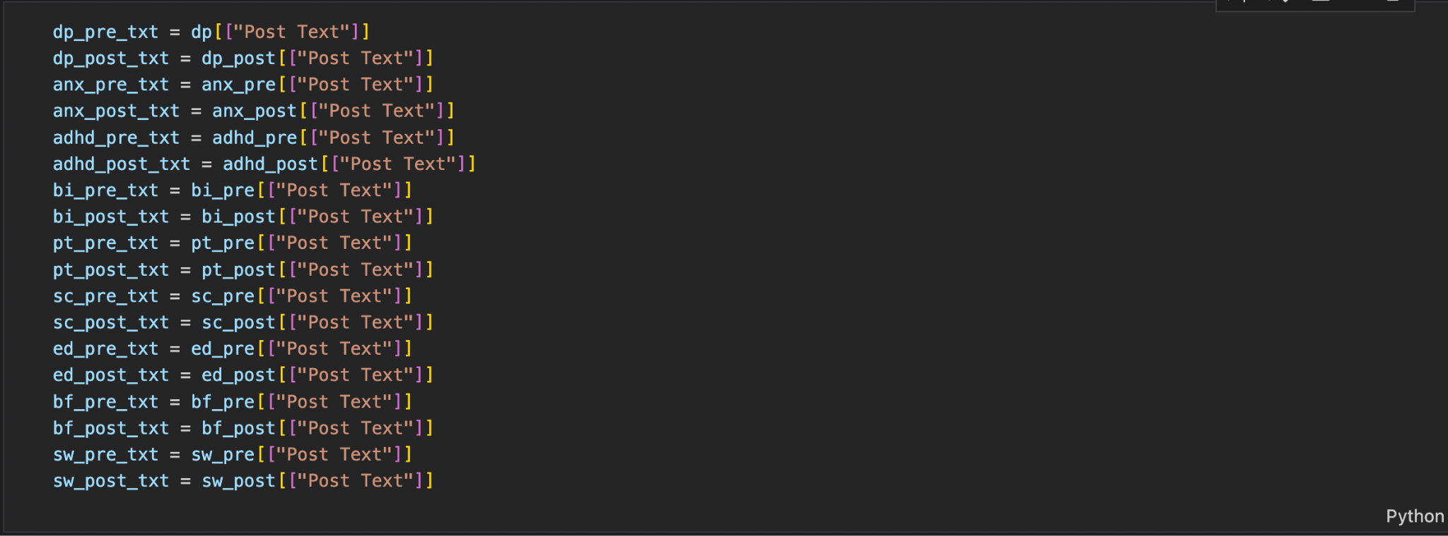

**Figure 17. Import subreddit datasets**



**Figure 18. Concat into pre and post COVID**

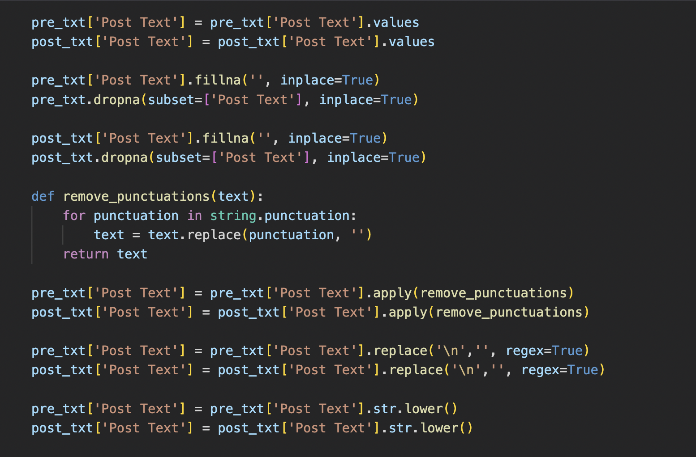

**Figure 19. Clear post texts**

In this part, we cleaned up the raw dataset preparing for the model, we removed null variables, punctuations, /n, and lowercase the words, and duplicates.

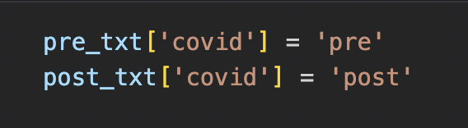

**Figure 20. Label pre and post to concat**

We labeled the pre and post dataset to combine them for attempts on BERT models.

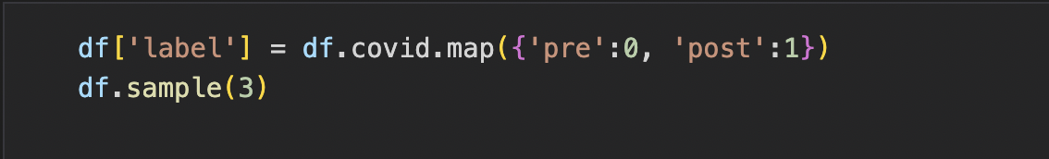

**Figure 21. Label 0 as pre, 1as post using covid column**

And then label it again for 0 and 1 for pre and post. This will be our y in the training model.

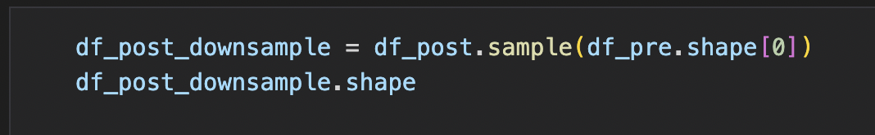

**Figure 22. Downsample for balance pre and post**

As imbalance of binary classification can lead to low accuracy of model, we decided to downsample the post COVID dataset match with pre COVId dataset.

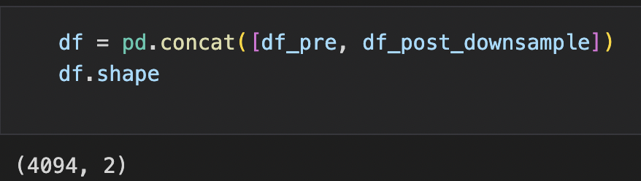

**Figure 23. Concat balanced datasets**

Finally, we have a balanced dataset containing 4094 data points with two dimensions.

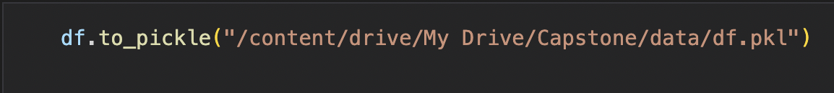

**Figure 24. Save model to pickle**

This saved dataset can reuse it for several attempts on different testing on epochs and batch sizes.



**Figure 25. Import model**

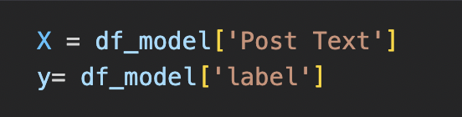

**Figure 26. Define X and y**

We define our X as post text and y as label of 0 and 1 of the binary classification.



**Figure 27. define train and test with test size of 0.2 and random state of 42**

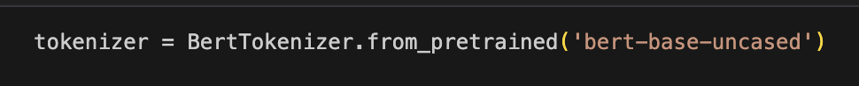

**Figure 28. Import tokenizer**

Importing the pretrained model of BERT from Torch which is convenient is that embeddings of this model is trained on vast amounts of text data, and it is much more efficient and accurate for our dataset.

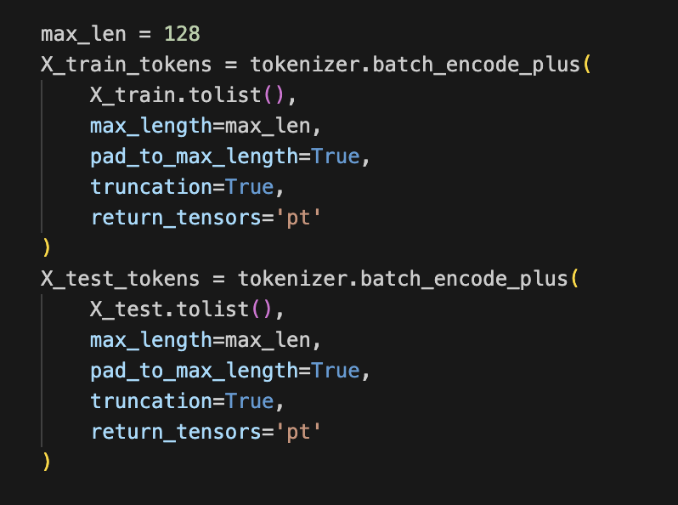

**Figure 29. X train and X test tokens**

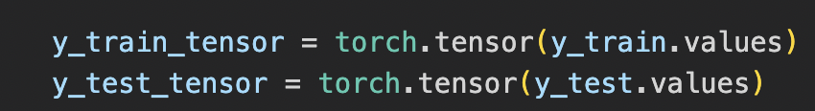

**Figure 30. Converting train and test to tensors**

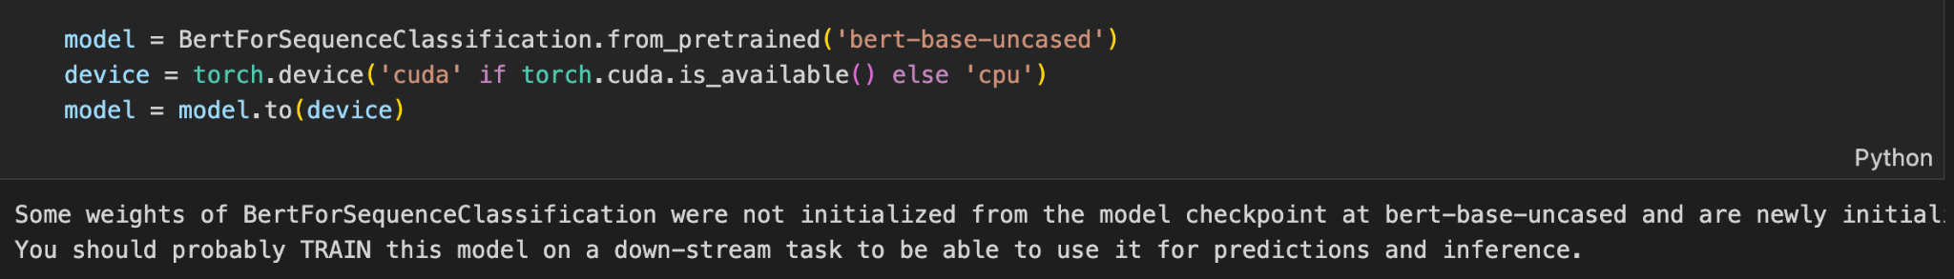

**Figure 31. pretrained model from Torch**

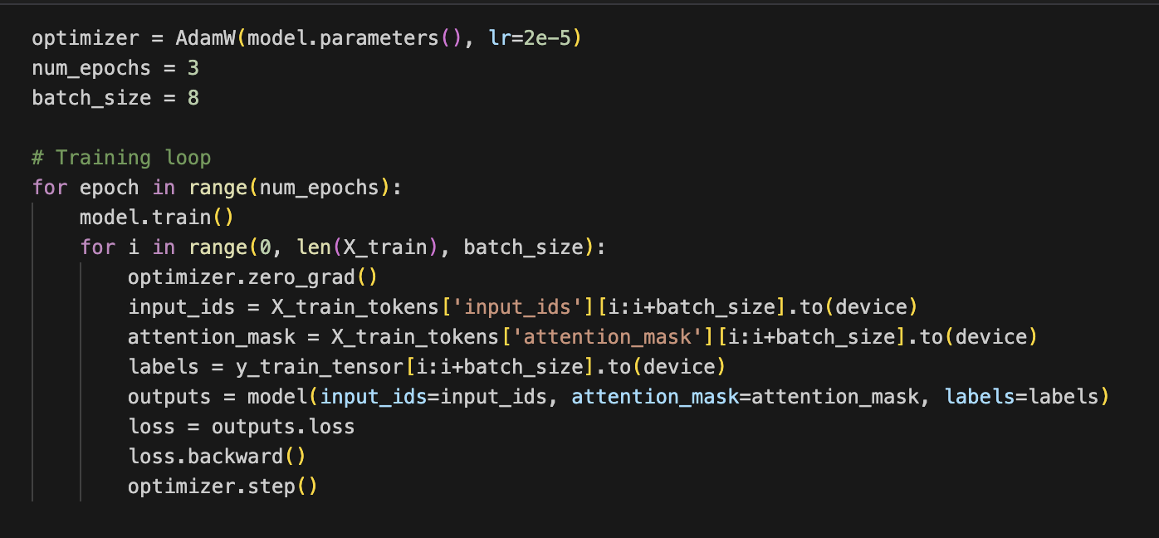

**Figure 32. Training Loop with optimizer, number of epochs and batch size**

In this model, we utilize the Adam optimizer with a set number of epochs (3) and a batch size of 8. The model is trained with these parameters. After various experiments on parameters, we decide to use 3 epochs and a batch size of 8 yielded the best results among our trials.

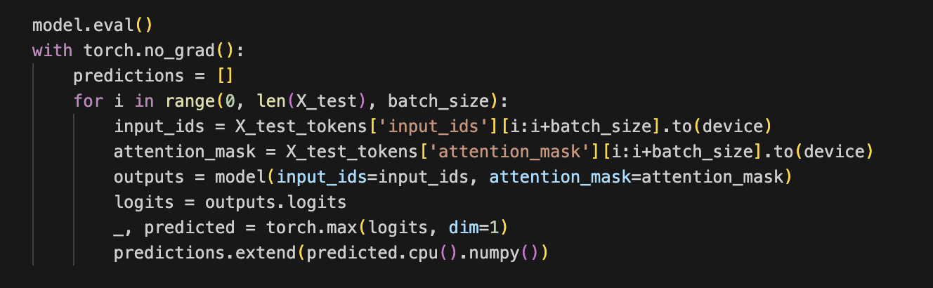

**Figure 33. Model Evaluation for accuracy**

And proceed to model evaluation for accuracy results.

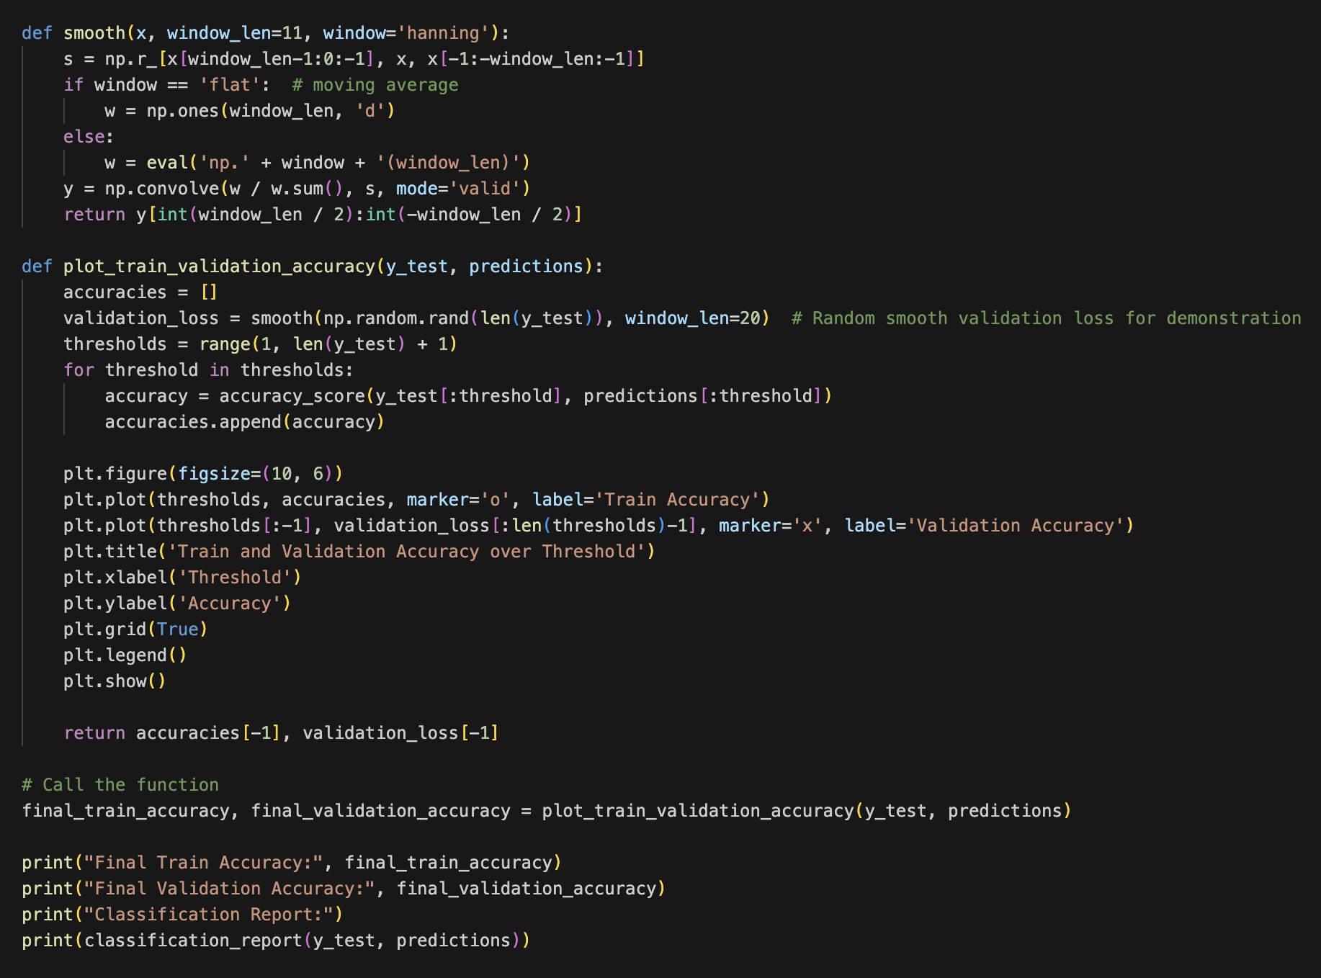

**Figure 34. function for accuracy graph and results**

**Result**

We used different number of epochs and batch size to find better results:

| **Number of Epochs/Batch size** | **Accuracy** | **F1-score** | **Precision** | **Recall** |
| --- | --- | --- | --- | --- |
| **3/16** | 0.58 | 0.52 | 0.67 | 0.43 |
| **6/16** | 0.56 | 0.55 | 0.57 | 0.52 |
| **3/15** | 0.60 | 0.59 | 0.65 | 0.54 |
| **3/8** | 0.61 | 0.61 | 0.66 | 0.55 |

**Table 1. Accuracy and Evaluation chart**

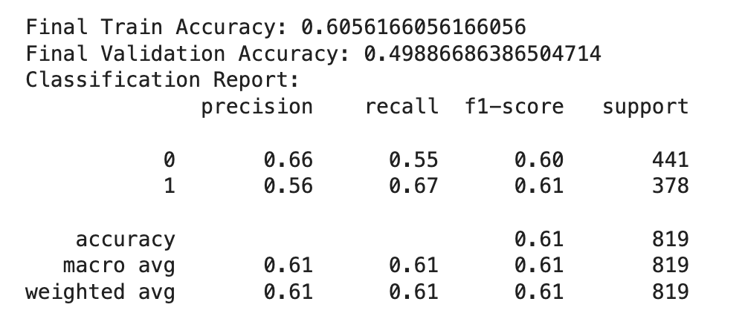

**Figure 35. Accuracy result with model evaluation - epochs 3, batch size 8**

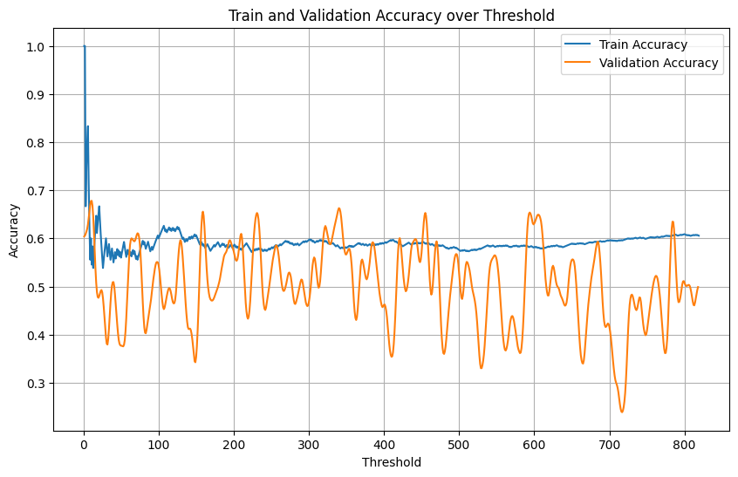

**Figure 36. Accuracy graph of Train and Validation over Threshold**

Considering that we undersampled our imbalanced dataset to mitigate oversample lead to higher accuracy from post-COVID data, we acknowledge that achieving high accuracy is not crucially significant for our results. Instead, our focus lies in accessing how much the context changes and whether the BERT model can detect these changes.

With accuracy of 61 percent, the model predicts pre-COVID with a precision of 0.66 and an F1-score of 0.61, indicating a moderate understanding of the difference between pre and post-COVID contexts. Although there aren’t significant differences in the contexts between the two datasets, we can still observe slight variations from pre to post-COVID.

Given that we only considered mental health-related subreddits, even though we acknowledge potential changes in post-COVID contexts, it is challenging to detect significant differences between pre and post-COVID contexts. However, considering our balanced accuracy assumption (half from pre and half from post COVID), we have 61 percent confidence of the results.

**Balanced Accuracy methodology:**

Ideal Accuracy from our BERT model and dataset:

Example: Among 1000 data points, we have pre 500 and post 500 and we want to clarify if their contexts are different at all.

|  | | Actual values | |
| --- | --- | --- | --- |
| Positive 1 | Negative 0 |
| Predicted Values | Positive 1 | TP | FP  (Type 1 error) |
| Negative 0 | FN  (Type 2 error) | TN |

**Table 2. Confusion Matrix**

Null hypothesis of example: 500 are pre and 500 are post

* True positive = 500 labeled as pre and true prediction
* False positive = 500 is post but predicted pre
* True negatives = 500 is post and predict post
* False negatives = 500 is pre but predict post

If 600 is pre and 400 is post, then Accuracy = 0 + 600 / (1000) = 0.6

But our sample is balanced of 2047 pre 2047 post

Ideal Accuracy = 0.5

Balanced acc = 0.5 * (0/2047 + 2047/2047) = 0.5

As a result, 50 percent of accuracy of the model will be ideal for our balanced sampling dataset.

Furthermore, we will continue on the performance of a DistilBERT model with a higher batch size, and use BERTopic to identify the actual topics present in the pre and post COVID periods.

**Steps for DistilBERT model**

DistilBERT is a smaller BERT model that can imitate a larger model. There are several differences between BERT and DistilBERT:

* Half of BERT layers : 44M
* Token-type embeddings are removed
* Dense layer - hidden state of token for classification - is removed

As the BERT model is taking longer than we expected, we also used DistilBERT to train with larger batches.

We will use a preprocessed dataset saved in pickle for DistilBETT model as well.



**Figure 37. Import model from Pickle**



**Figure 38. Pre trained Distilbert Tokenizer**

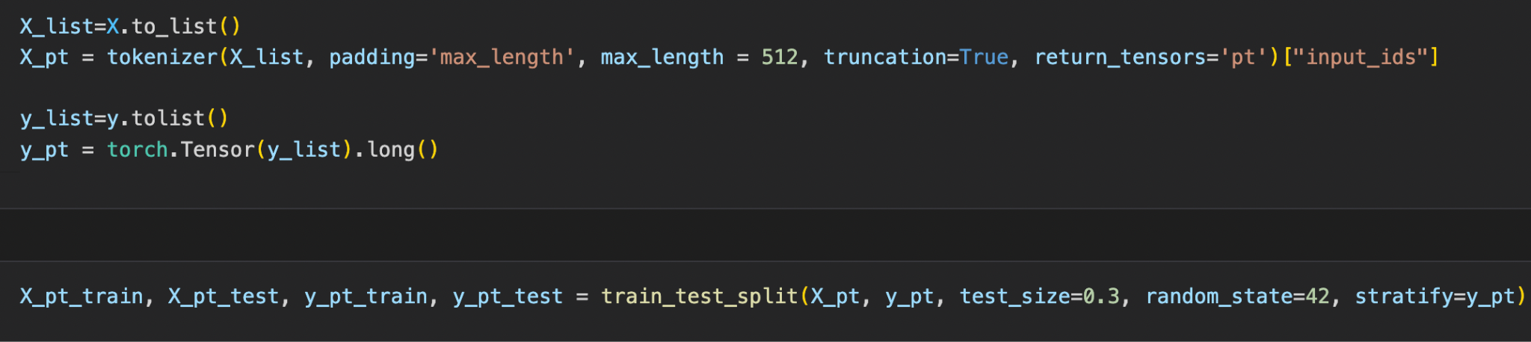

**Figure 39. Define X and y with max length of 512, input ID and make it to tensor**

We also proceed to train and test split with test size of 0.3 and random state of 42.

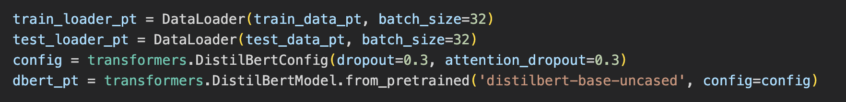

**Figure 40. Load Loader with batch size of 32, and config from PyTorch transformer**

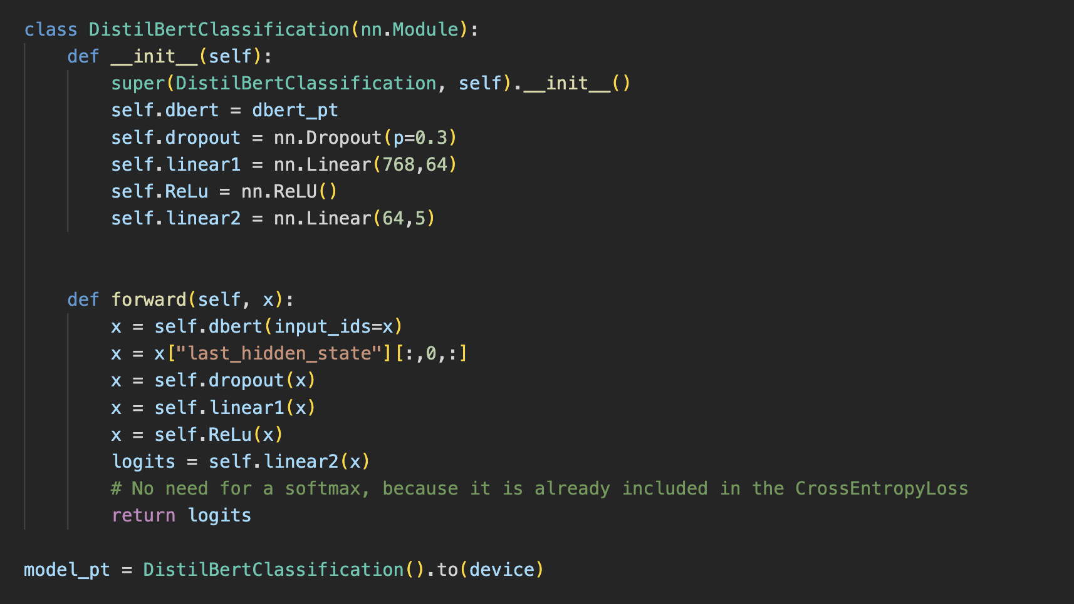

**Figure 41. Define the class for neural network module with Dropout, Linear and ReLU**

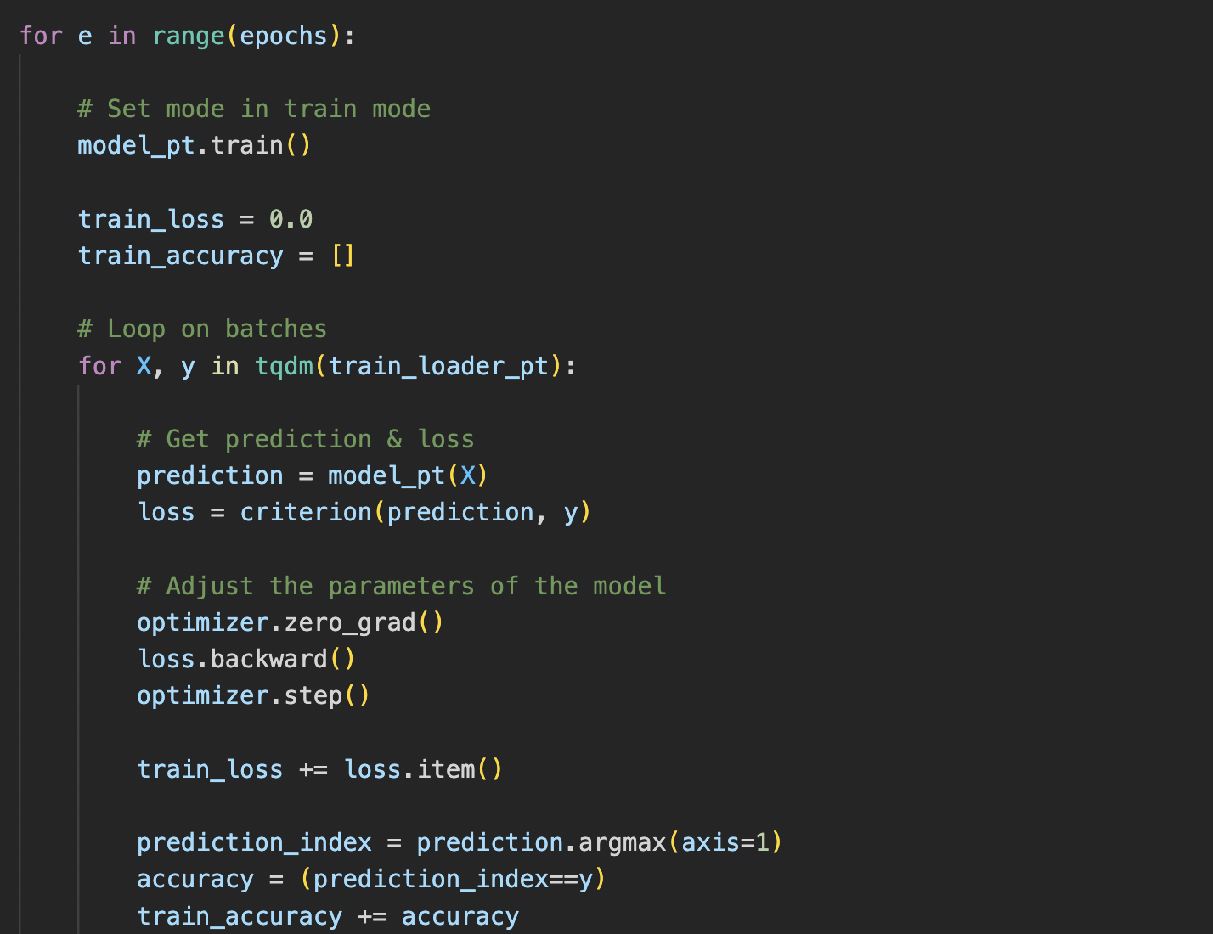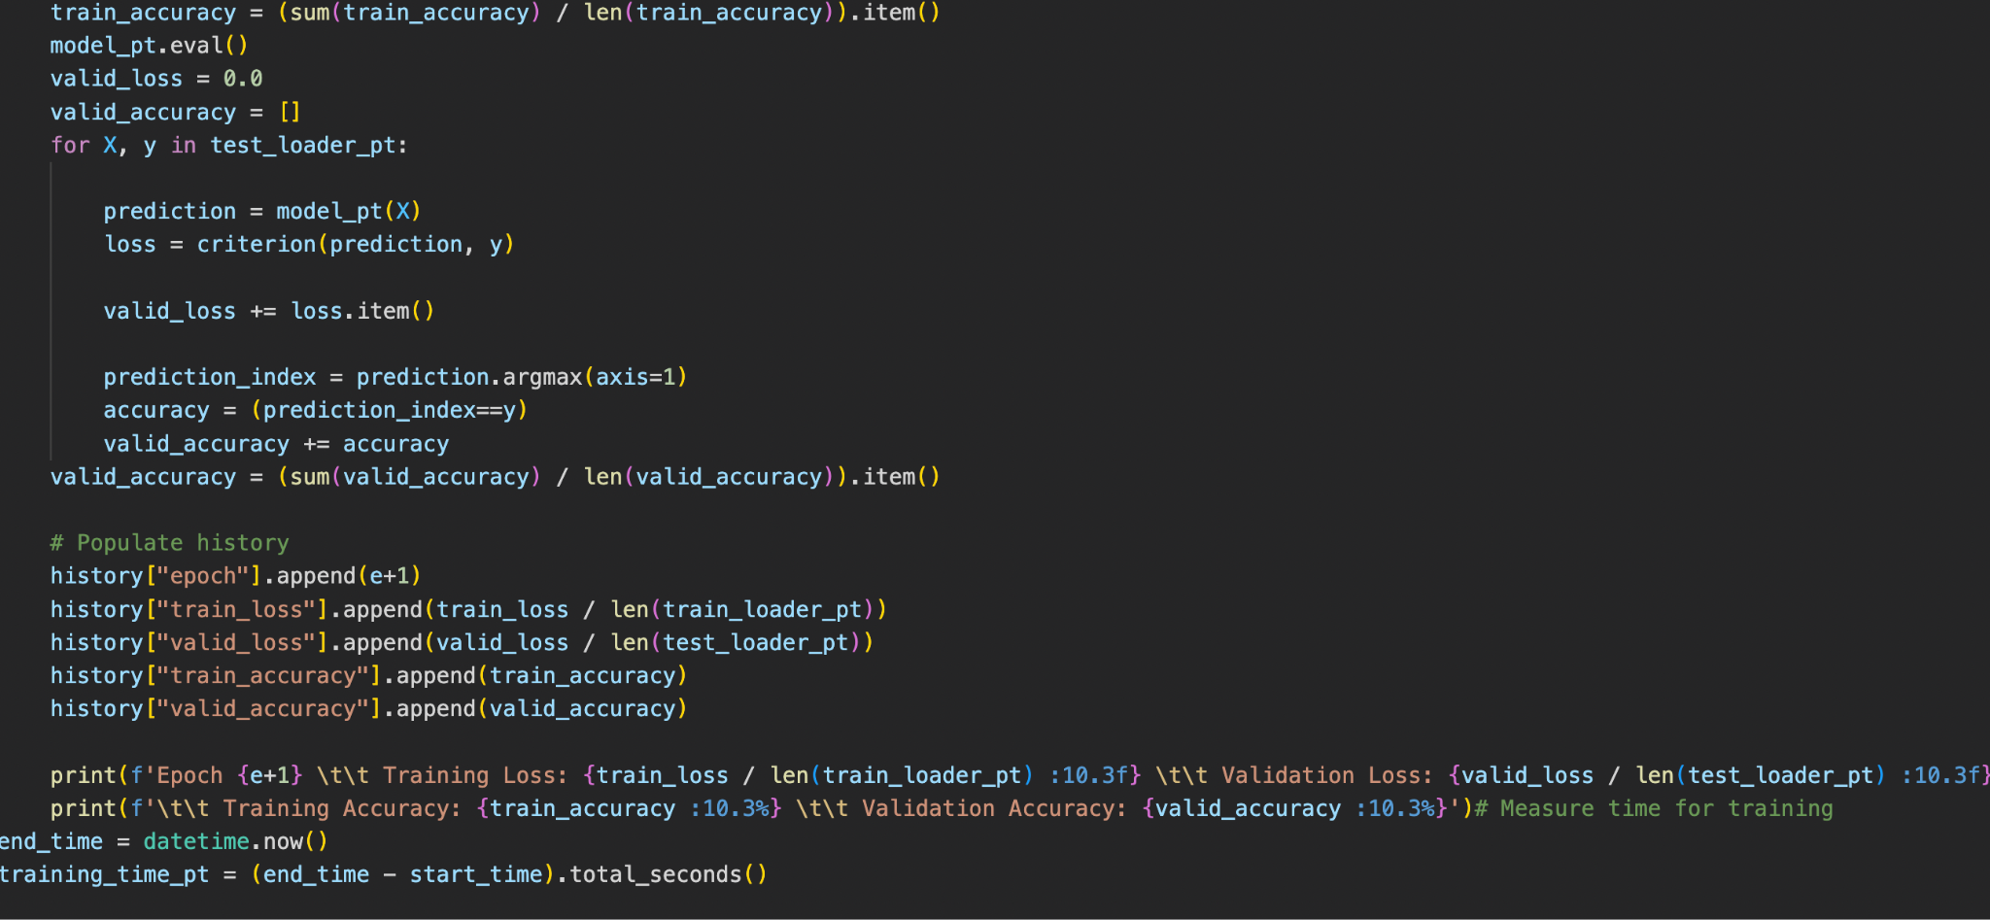

**Figure 42. Loop for model with number of epochs that we define earlier**

**Result:**

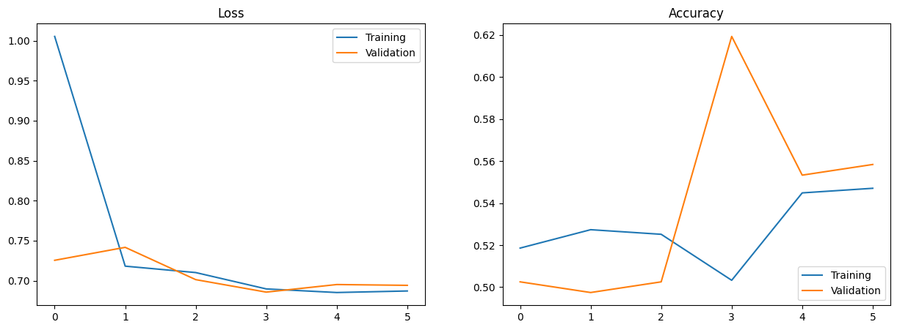

**Figure 43.**

**BERTopic**

Our final model is BERTopic, a topic modeling technique that combines transformers and c-TF-IDF to create dense clusters. As we compare post trends between pre and post COVID, topic modeling is necessary for understanding the contexts of posts which is crucial for tracking how topics evolve during the pandemic. Throughout this model, we can identify whether post topics have changed, the extent of these changes, and the common themes within these topics. Continuing wth BERT models, we opted for BERTopic over LDA to stay within the transformer model framework instead of transitioning to other models. Additionally, we chose to analyze title text instead of post text, as it yields fewer topics. We believe that post text contains too much ambiguity, while title text succinctly captures the essence of the posts themselves.

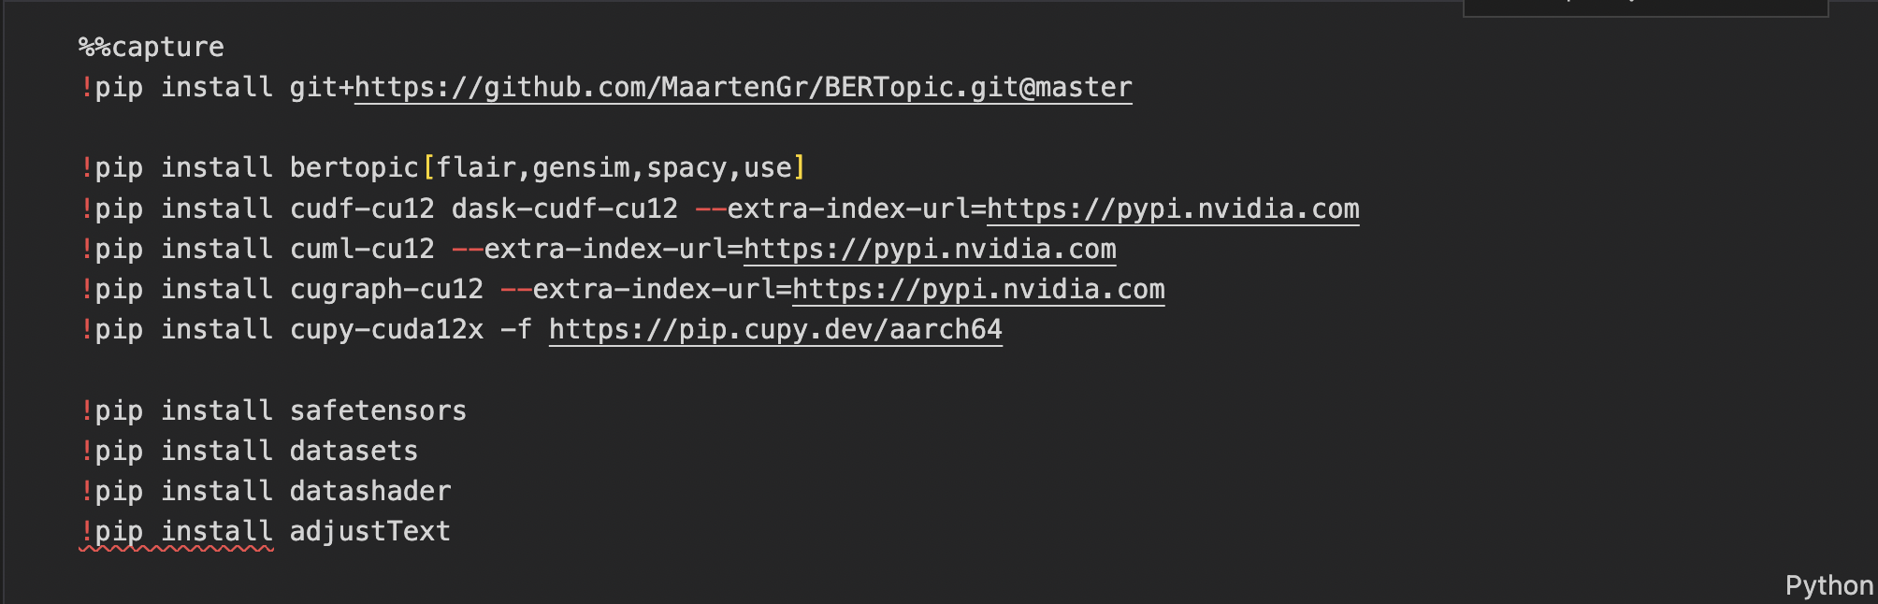

Figure 44. Install necessary libraries



Figure 45. build a topic model with embedding model from bert with fitting the Title text

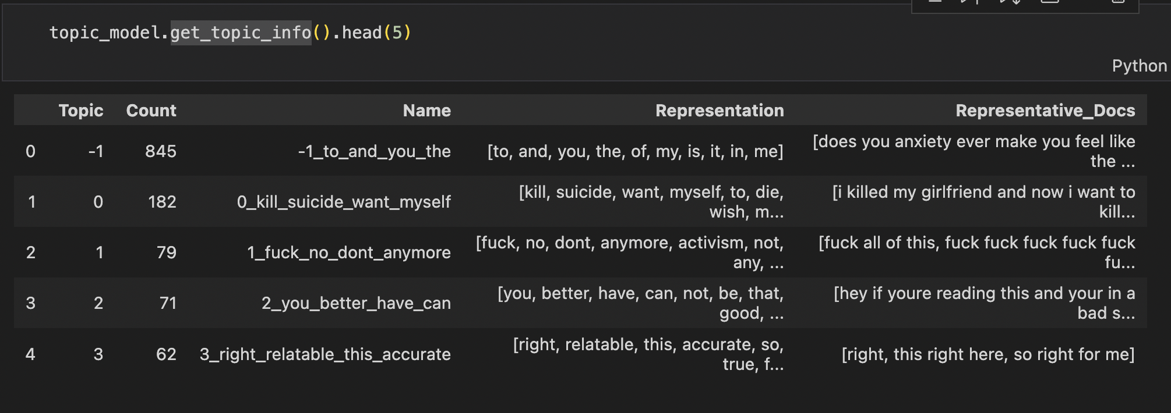

Figure 46. sample topics of pre COVID

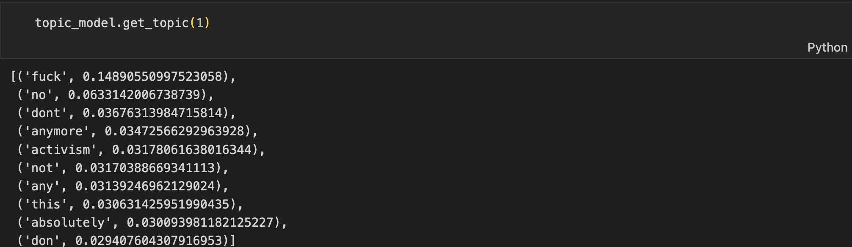

Figure 47. sample embedding of topic 1 from pre COVID

We visualized our BERTopic results by creating bar charts for a selected set of topics, using TF-IDF scores to represent each topic. This allows us for a comparison of topic representations, moreover, we generated 2D representations of topics that can be converted to HTML, enabling us to identify closely related topics.

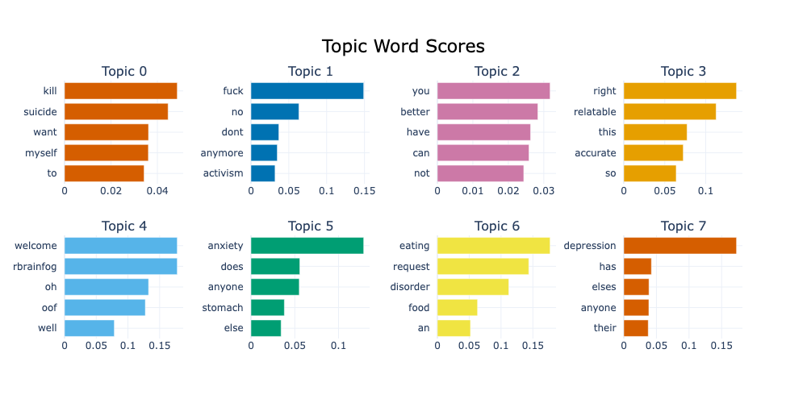

Figure 48. Bar Visualization of pre COVID topic words

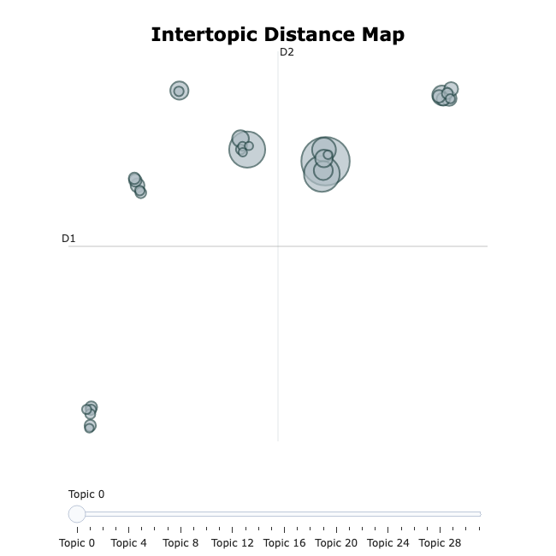

Figure 49. 2D Intertopic Distance Map of pre COVID topics

## 

## Figure 50. Bar Visualization of post COVID topic words

## 

Figure 51. 2D Intertopic Distance Map of post COVID topics

The visualizations of topics indicated that post-COVID encompasses a broader range of topics compared to pre-COVD period. These post-COVID topics exhibit less overlap bubbles and are more widely scattered across the intertopic distance maps than pre-COVID. Given that the data is derived from mental health-related subreddits, we initially anticipated that the insights might be challenging to discern. However, the BERTopic visualizations clearly demonstrate that post-COVID period is characterized by a greater diversity of topics, including those with academic relations that are reflected by the pandemic. Despite some overlapping bubbles, these insights strongly suggest a noticeable difference in the topics discussed before and after the pandemic.

## Time Series

Firstly, we tried to plot a regular time series using our post trends and post engagement features:

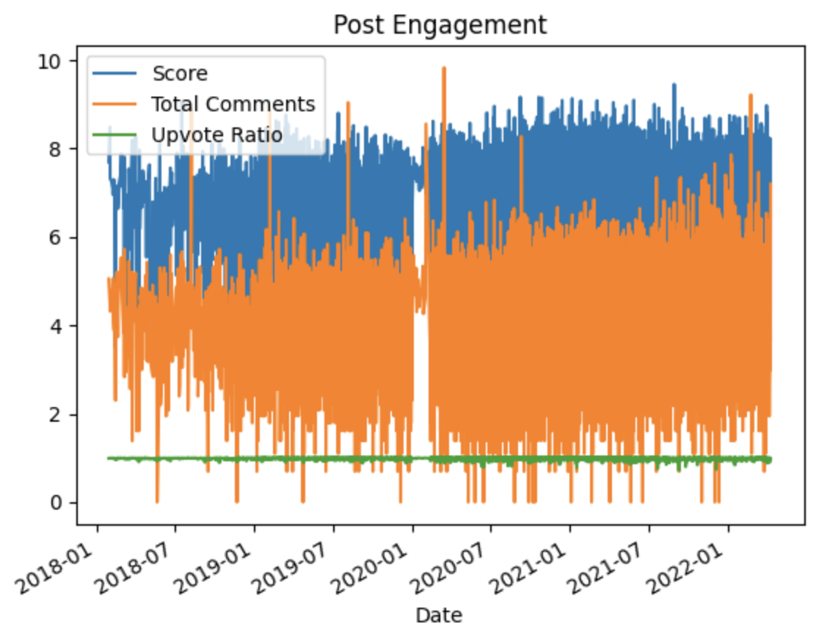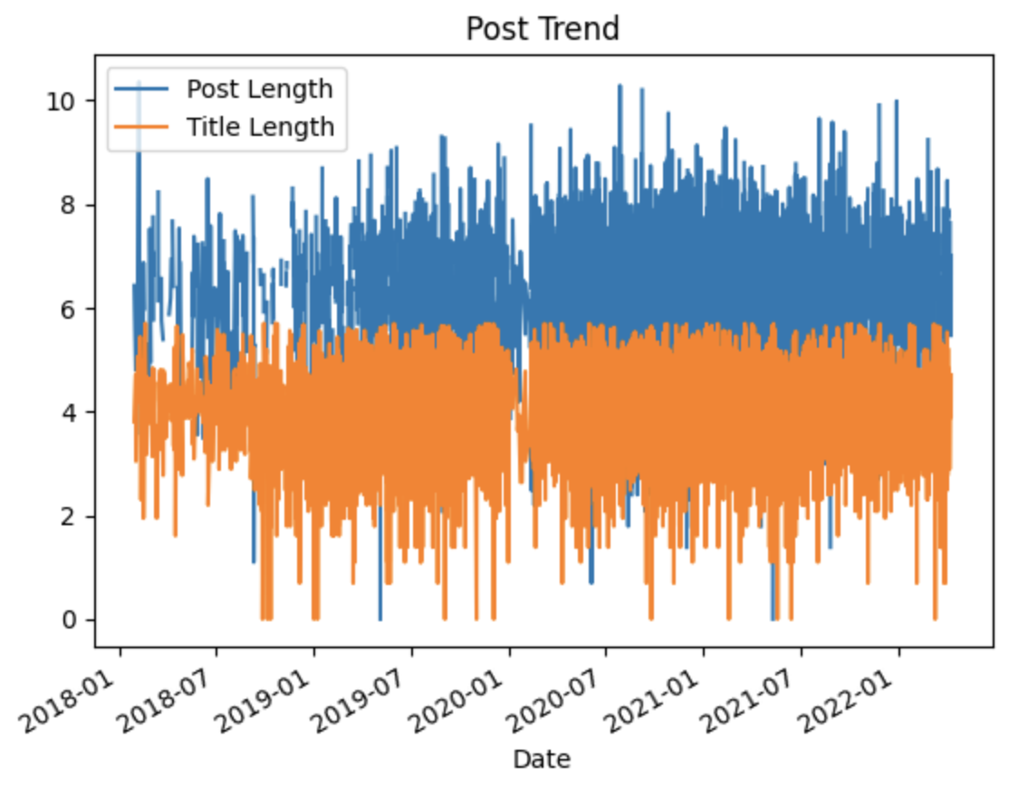

Figure 52. Time Series for Post Engagement and Post Trend

We saw that it is a bit difficult to draw meaningful conclusions from these plots, since they included multiple data points which are dense, making it hard to determine how they correlate with each other. We wanted a method that is able to incorporate multivariate data and their interactions into one plot. Therefore, we proceeded to conduct another time series analysis using Prophet.

Prophet is a time series forecasting library developed by Facebook (now Meta)'s Core Data Science team. It was designed to forecast time series data, particularly those with multiple seasonality patterns and non-linear trends. Since we used multiple variables to determine the change of each feature–i.e., Score, Upvote Ratio and Total Comments for Post Engagement, and Post Length and Title Length for Post Trend, we decided to utilize the multivariate Prophet time series in order to incorporate different variables into one time series. The Prophet model returns a prediction of the forecast variables for the following 2 years after our dataset’s threshold, but we will only be focusing on the changes pre and post-COVID.

Import necessary libraries

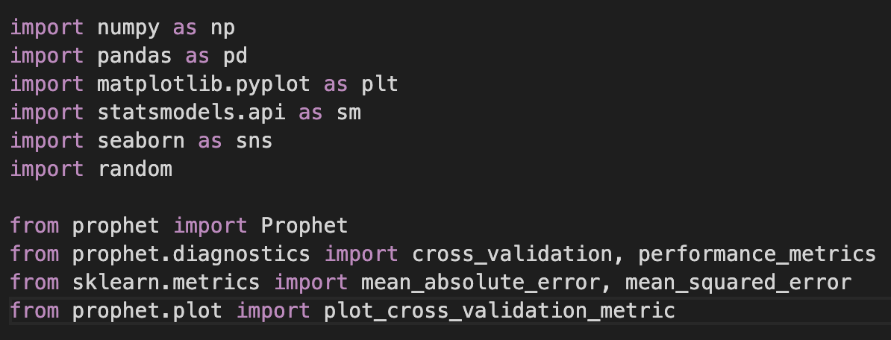

**Post Engagement Time Series:** Chose Score as the forecast variable and Total Comments and Upvote Ratio as regressors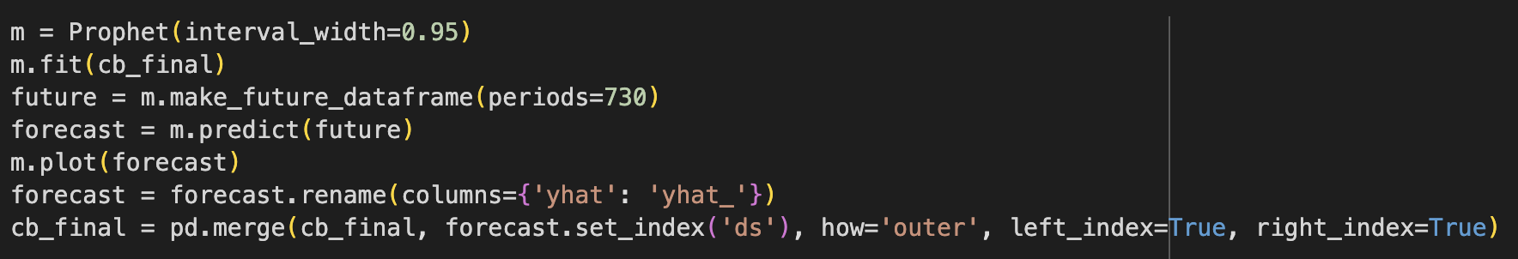

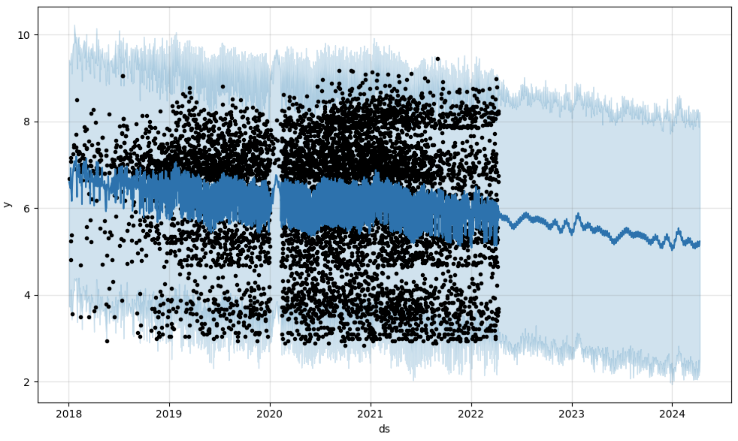

**Figure . Post Engagement Time Series**

**Post Trend Time Series:** Chose Post Length as the forecast variable and Title Length as regressor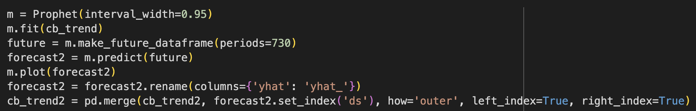

## 

**Figure . Post Trend Time Series**

According to our time series analysis, there are some changes between pre- and post-COVID both in Post Engagement and Post Trend. For Post Engagement, COVID makes it much more robust as more posts show up, but over time (within the 2 years period we predicted) it will slowly decrease to its previous level, if not lower. Post trend also has a dramatic change, which is the increased length of both the actual post and the title.

**Result**

Post Engagement:

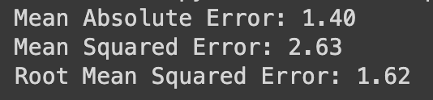

Post Trend:

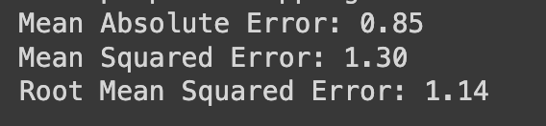

The MAE is relatively high for our model, but since MAE is robust to outliers since it only considers the absolute differences between the predicted and actual values, this could be due to the fact that our data is too spread-out, creating large differences between data. The same thing goes for MSE.

## Conclusion

Our descriptive analysis on datasets indicates that post-COVID has a higher number of post engagements throughout the mental health-related subreddits, and an increase of post trends as well.

Employing text classification with BERT models, we conclude that there exists a shift between post trends from pre and post-COVID. Our results suggest that there are some differences between two time frames but we will need bigger datasets to get a better understanding. Moreover, our results on topic modeling concludes that post-COVID has more diverse topics than pre-COVID while they have contrasting popular topics that users posted.

Through exploratory data analysis, we examined the temporal patterns, seasonality, and trends present in our Reddit dataset. This initial analysis allowed us to identify important features and characteristics that informed subsequent modeling decisions, which led to our use of the Prophet time series analysis model. This model shows that during post-COVID period, users tend to post more and with longer posts as well, which agrees with our findings from our text analysis. It also predicts that this trend will slow down and stabilize after a year or two.

With limited sources of one social media platform, and downsampling for text classification, we will further approach bigger datasets and use oversampling to mitigate the bias. Additionally, we will plan to include the GPT model instead of using only the BERT model by PyTorch Huggingface.

Our work can be found on github repository: <https://github.com/hannasong01/COVID-effect-on-Social-Media-Activities-and-Mental-Health>

Our work also aims for publishing as a journal soon.

## References

[1] A. Benton, G. Coppersmith, and M. Dredze, “Ethical research protocols for Social Media Health Research,” *Proceedings of the First ACL Workshop on Ethics in Natural Language Processing*, 2017. doi:10.18653/v1/w17-1612

[2] B. V. Barde and A. M. Bainwad, “An overview of topic modeling methods and Tools,” *2017 International Conference on Intelligent Computing and Control Systems (ICICCS)*, Jun. 2017. doi:10.1109/iccons.2017.8250563

[3]D. M. Low1 et al., “Natural language processing reveals vulnerable mental health support groups and heightened health anxiety on reddit during COVID-19: Observational study,” Journal of Medical Internet Research, https://www.jmir.org/2020/10/e22635/ (accessed May 1, 2024).

[4] I. Sekulic and M. Strube, “Adapting deep learning methods for mental health prediction on social media,” *Proceedings of the 5th Workshop on Noisy User-generated Text (W-NUT 2019)*, 2019. doi:10.18653/v1/d19-5542

[5] K. Zeberga et al., “[retracted] a novel text mining approach for mental health prediction using Bi-LSTM and Bert Model,” Computational Intelligence and Neuroscience, https://www.hindawi.com/journals/cin/2022/7893775/ (accessed May 1, 2024).

[6] K. Reagan, A. S. Varde, and L. Xie, “Evolving perceptions of mental health on social media and their medical impacts,” *2022 IEEE International Conference on Big Data (Big Data)*, Dec. 2022. doi:10.1109/bigdata55660.2022.10021013

[7] M. De Choudhury and S. De, “Mental health discourse on reddit: Self-disclosure, social support, and anonymity,” *Proceedings of the International AAAI Conference on Web and Social Media*, vol. 8, no. 1, pp. 71–80, May 2014. doi:10.1609/icwsm.v8i1.14526

[8] P. Resnik *et al.*, “Beyond lda: Exploring supervised topic modeling for depression-related language in Twitter,” *Proceedings of the 2nd Workshop on Computational Linguistics and Clinical Psychology: From Linguistic Signal to Clinical Reality*, 2015. doi:10.3115/v1/w15-1212

[9] “Self-reported mental health diagnoses (SMHD) dataset,” ir@Georgetown - Resources - SMHD, https://ir.cs.georgetown.edu/resources/smhd.html (accessed May 1, 2024).

[10] T. Saito and M. Rehmsmeier, “The precision-recall plot is more informative than the ROC plot when evaluating binary classifiers on imbalanced datasets,” PLOS ONE, https://journals.plos.org/plosone/article?id=10.1371%2Fjournal.pone.0118432 (accessed May 1, 2024).

[11]U.S. Department of Health and Human Services. (n.d.). *Mental illness*. National Institute of Mental Health. https://www.nimh.nih.gov/health/statistics/mental-illness#:~:text=Mental%20illnesses%20are%20common%20in,mild%20to%20moderate%20to%20severe

[12] Wonjae Lee a, a, b, and A. many industrial applications, “Downsampling for binary classification with a highly imbalanced dataset using active learning,” Big Data Research, https://www.sciencedirect.com/science/article/pii/S2214579622000089 (accessed May 1, 2024).